* Create a EC2 instance name(3-tier-hq)
AMI Use : Ubuntu
instance type: t2.micro

Open an SSH client.
ssh -i "baniprasad-key.pem" ubuntu@108.131.130.182

go to the GitHub copy the Git : https://github.com/BaniprasadMangaraj/aws-eks-3tier-deployment.git, and then got the terminal then run

clone the code : git clone https://github.com/BaniprasadMangaraj/aws-eks-3tier-deployment.git

then go to the path and create the docker file
- ubuntu@ip-10-0-0-125:~/aws-eks-3tier-deployment$ cd Application-Code/
-ls
-backend frontend

#Install Docker
sudo apt-get update
sudo apt install docker.io

#Add your user to docker group
sudo usermod -aG docker $USER
newgrp docker

create docker file frontend
cd frontend

/? This is React Frontend
package.json vs package-lock.json
🟢 package.json (YOU write / maintain this)

What it is

Main configuration file for a Node.js project

Tells npm:

project name & version

scripts

which dependencies your app needs

Example

{
"name": "frontend-app",
"version": "1.0.0",
"scripts": {
"start": "node index.js"
},
"dependencies": {
"express": "^4.18.2"
}
}

Key points

You edit this manually

Contains dependency ranges

Used by developers to understand the project

🔵 package-lock.json (AUTO-generated by npm)

What it is

Exact snapshot of installed dependencies

Records:

exact versions

dependency tree

resolved URLs

integrity hashes

Example

"express": {
"version": "4.18.2",
"resolved": "https://registry.npmjs.org/express/-/express-4.18.2.tgz",
"integrity": "sha512-..."
} ?/

/Run Use for create intermediate layer but CMD user for something entry

frontend docker file : FROM node:14
WORKDIR /usr/src/app
COPY package*.json ./
RUN npm install
COPY . .
CMD [ "npm", "start" ]

#Build the frontend chek its working or not
docker build -t threetier-frontend .

#Run the container
docker run -d -p 3000:3000 threetier-frontend:latest

then go to the aws instance and then go security then enable the 3000 port for frontend
http://108.131.130.182:3000/

#after test Container stopped immediately or kill
docker kill a0d51a457ed4

#Next is push the frontend Image to the AWS ECR
prequisit

go to the instance and move home directory

#Install AWS CLI v2

curl "https://awscli.amazonaws.com/awscli-exe-linux-x86_64.zip" -o "awscliv2.zip"
sudo apt install unzip
unzip awscliv2.zip
sudo ./aws/install -i /usr/local/aws-cli -b /usr/local/bin --update
aws configure

# IAM Configuration
Create a user eks-admin with AdministratorAccess.
Generate Security Credentials: Access Key and Secret Access Key.

#Then Serach ECR and Go to the ECR
creta repo name :three-tier-frontend

#Click View push Command

and run in the instance

1.Retrieve an authentication token and authenticate your Docker client to your registry. Use the AWS CLI:
aws ecr get-login-password --region eu-west-1 | docker login --username AWS --password-stdin 282293004053.dkr.ecr.eu-west-1.amazonaws.com

2.Build your Docker image using the following command. For information on building a Docker file from scratch see the instructions here . You can skip this step if your image is already built:

go the frontend path run the command
:docker build -t three-tier-frontend .

3.After the build completes, tag your image so you can push the image to this repository:
docker tag three-tier-frontend:latest 282293004053.dkr.ecr.eu-west-1.amazonaws.com/three-tier-frontend:latest

4.Run the following command to push this image to your newly created AWS repository:
docker push 282293004053.dkr.ecr.eu-west-1.amazonaws.com/three-tier-frontend:latest

*******
Then Move to backend Docker File

FROM node:14
WORKDIR /usr/src/app
COPY package*.json ./
RUN npm install
COPY . .
CMD ["node", "index.js"]

node js run index.js everything here.

then push to the ecr

1. Retrieve an authentication token and authenticate your Docker client to your registry. Use the AWS CLI:
aws ecr-public get-login-password --region us-east-1 | docker login --username AWS --password-stdin public.ecr.aws/a5v7p0i9

2. Build your Docker image using the following command. For information on building a Docker file from scratch see the instructions here . You can skip this step if your image is already built:

docker build -t three-tier-backend .

3. After the build completes, tag your image so you can push the image to this repository:
docker tag three-tier-backend:latest public.ecr.aws/a5v7p0i9/three-tier-backend:latest

4. Run the following command to push this image to your newly created AWS repository:
docker push public.ecr.aws/a5v7p0i9/three-tier-backend:latest

some issue is arise Could not connect to database this things sloves attached Database, this use when deploy in eks.

ECR Frontend Name: three-tier-frontend
ECR Backend Name : three-tier-backend

******************

Now EKS Work:

*Install kubectl in Instance, Move to home Directory

curl -o kubectl https://amazon-eks.s3.us-west-2.amazonaws.com/1.19.6/2021-01-05/bin/linux/amd64/kubectl
chmod +x ./kubectl
sudo mv ./kubectl /usr/local/bin
kubectl version --short --client

* Install eksctl

curl --silent --location "https://github.com/weaveworks/eksctl/releases/latest/download/eksctl_$(uname -s)_amd64.tar.gz" | tar xz -C /tmp
sudo mv /tmp/eksctl /usr/local/bin
eksctl version

*Setup EKS Cluster

- eksctl create cluster --name three-tier-cluster --region eu-west-1 --node-type t3.small --nodes-min 2 --nodes-max 2 ( Taking Creata EKS Cluster 15 to 20 min)
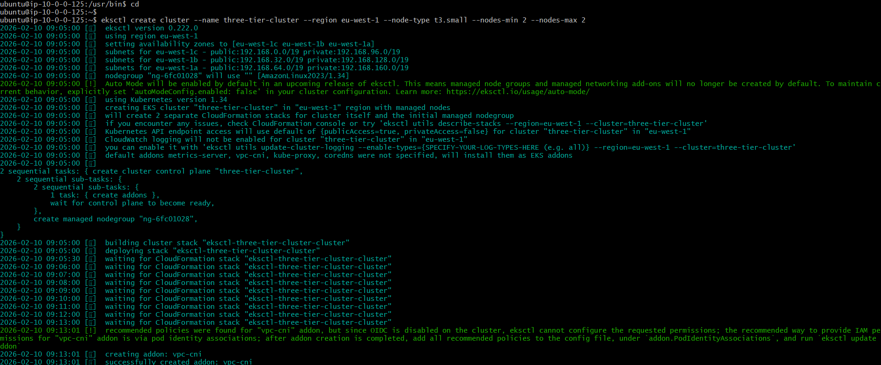

#It connects your local machine (EC2 / laptop) to your EKS cluster so that kubectl knows which cluster to talk to and how.(If you have multiple cluster then kubctl points this cluster)

- aws eks update-kubeconfig --region eu-west-1 --name three-tier-cluster

(ubuntu@ip-10-0-0-125:~$ aws eks update-kubeconfig --region eu-west-1 --name three-tier-cluster
Added new context arn:aws:eks:eu-west-1:282293004053:cluster/three-tier-cluster to /home/ubuntu/.kube/config)

- kubectl get nodes

***********************
Next Creata the Deployemnt manifest file

first create for database:

- cd aws-eks-3tier-deployment/Kubernetes-Manifests-file/Database

* first crt the secrets.yaml for store the secrets file

apiVersion: v1
kind: Secret
metadata:
namespace: three-tier
name: mongo-sec
type: Opaque
data:
password: QWRtaW4xMjMK #Admin123 (Genrate Base64 command : echo "Admin123" | base64, if want to decode the base 64 command is : echo "QWRtaW4xMjMK" | base64 --decode)
username: YWRtaW4= #admin

* Second crt the deployment.yaml

apiVersion: apps/v1
kind: Deployment
metadata:
namespace: three-tier
name: mongodb
spec:
replicas: 1
selector:
matchLabels:
app: mongodb
template:
metadata:
labels:
app: mongodb
spec:
containers:
- name: mon
image: mongo:4.4.6
command:
- "numactl"
- "--interleave=all"
- "mongod"
- "--wiredTigerCacheSizeGB"
- "0.1"
- "--bind_ip"
- "0.0.0.0"
ports:
- containerPort: 27017
env:
- name: MONGO_INITDB_ROOT_USERNAME
valueFrom:
secretKeyRef:
name: mongo-sec #secrets file name
key: username #key name
- name: MONGO_INITDB_ROOT_PASSWORD
valueFrom:
secretKeyRef:
name: mongo-sec
key: password
volumeMounts:
- name: mongo-volume
mountPath: /data/db
volumes:
- name: mongo-volume
persistentVolumeClaim:
claimName: mongo-volume-claim

*Sevice crete to connect with backend service.yaml

apiVersion: v1
kind: Service
metadata:
namespace: three-tier
name: mongodb-svc
spec:
selector:
app: mongodb
ports:
- name: mongodb-svc
protocol: TCP
port: 27017
targetPort: 27017

#URL create and attch with backend : mongodb://mongodb-svc:27017/todo?directConnection=true

(1️⃣ mongodb://

Protocol for MongoDB

Tells the driver: “Use MongoDB to connect”

2️⃣ mongodb-svc

Hostname

In Kubernetes, this is a Service name, not an IP

👉 That means:

MongoDB is running in a Pod

Exposed via a Service called mongodb-svc

Kubernetes DNS resolves it automatically

So inside the cluster:

mongodb-svc → MongoDB Pod IP

📌 This works only inside the same Kubernetes cluster / namespace.

3️⃣ :27017

MongoDB default port

Service forwards traffic on this port to the MongoDB Pod

4️⃣ /todo

Database name

MongoDB will:

Connect to database todo

Create it automatically if it doesn’t exist

5️⃣ ?directConnection=true

Query parameter

Forces the client to connect directly to a single MongoDB instance)

Run Manifests:

kubectl create namespace three-tier
kubectl apply -f .
kubectl delete -f .

* kubectl apply -f deployment.yaml

o/p: deployment.apps/mongodb created

*kubectl get deployment -n three-tier

o/p:NAME READY UP-TO-DATE AVAILABLE AGE
mongodb 1/1 1 1 8m13s

*kubectl apply -f secrets.yaml

*service creation :

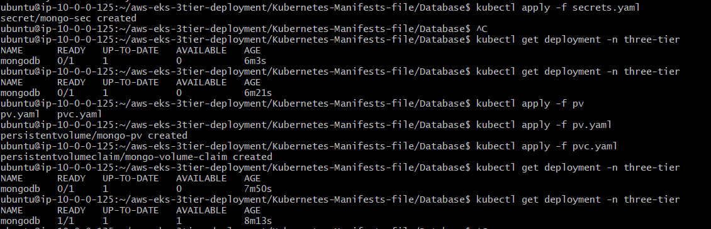

Now Move to run Backend
- Crt Deployement.yaml

- apiVersion: apps/v1
- kind: Deployment
- metadata:
- name: api
- namespace: three-tier
- labels:
- role: api
- env: demo
- spec:
- replicas: 2
- strategy:
- type: RollingUpdate
- rollingUpdate:
- maxSurge: 1
- maxUnavailable: 25%
- selector:
- matchLabels:
- role: api
- template:
- metadata:
- labels:
- role: api
- spec:
- imagePullSecrets:
- - name: ecr-registry-secret
- containers:
- - name: api
- image: public.ecr.aws/a5v7p0i9/three-tier-backend:latest
- imagePullPolicy: Always
- env:
- - name: MONGO_CONN_STR
- value: mongodb://mongodb-svc:27017/todo?directConnection=true
- - name: MONGO_USERNAME
- valueFrom:
- secretKeyRef:
- name: mongo-sec
- key: username
- - name: MONGO_PASSWORD
- valueFrom:
- secretKeyRef:
- name: mongo-sec
- key: password
- ports:
- - containerPort: 3500
- livenessProbe:
- httpGet:
- path: /ok
- port: 3500
- initialDelaySeconds: 2
- periodSeconds: 5
- readinessProbe:
- httpGet:
- path: /ok
- port: 3500
- initialDelaySeconds: 5
- periodSeconds: 5
- successThreshold: 1

- Crt Service.yaml

- apiVersion: v1
- kind: Service
- metadata:
- name: api
- namespace: three-tier
- spec:
- ports:
- - port: 3500
- protocol: TCP
- type: ClusterIP
- selector:
- role: api

** Pods Get Command
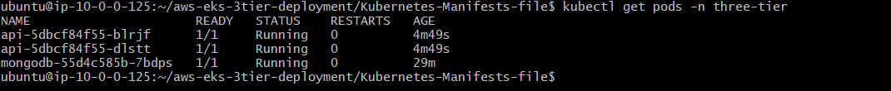

** Logs Chk
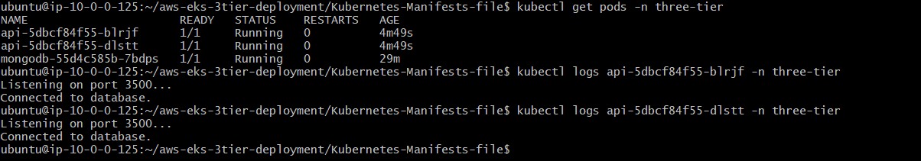

Next Is Frontend:
*Deployment.yaml
apiVersion: apps/v1
kind: Deployment
metadata:
name: frontend
namespace: three-tier
labels:
role: frontend
env: demo
spec:
replicas: 1
strategy:
type: RollingUpdate
rollingUpdate:
maxSurge: 1
maxUnavailable: 25%
selector:
matchLabels:
role: frontend
template:
metadata:
labels:
role: frontend
spec:
imagePullSecrets:
- name: ecr-registry-secret
containers:
- name: frontend
image: public.ecr.aws/a5v7p0i9/three-tier-frontend
imagePullPolicy: Always
env:
- name: REACT_APP_BACKEND_URL
value: "http://backend.amanpathakdevops.study/api/tasks"
ports:
- containerPort: 3000

*Service.yaml
apiVersion: v1
kind: Service
metadata:
name: frontend
namespace: three-tier
spec:
ports:
- port: 3000
protocol: TCP
type: ClusterIP
selector:
role: frontend

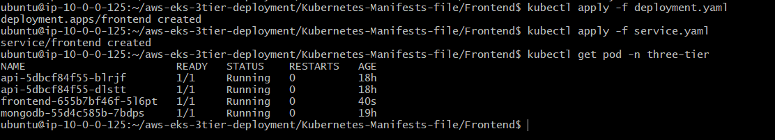

Now Use Ingress Controller (Ingress is a Kubernetes API object that manages external HTTP/HTTPS access to services inside a cluster.)
Instead of exposing services using:
- ❌ NodePort
- ❌ LoadBalancer (multiple costly LBs)
You use:
- ✅ One Ingress Controller
- ✅ One Load Balancer
- ✅ Route traffic based on host/path
- An Ingress Controller is the actual traffic handler.

Install AWS Load Balancer:
Cd
curl -O https://raw.githubusercontent.com/kubernetes-sigs/aws-load-balancer-controller/v2.5.4/docs/install/iam_policy.json
aws iam create-policy --policy-name AWSLoadBalancerControllerForIAMPolicy --policy-document file://iam_policy.json

O\P: 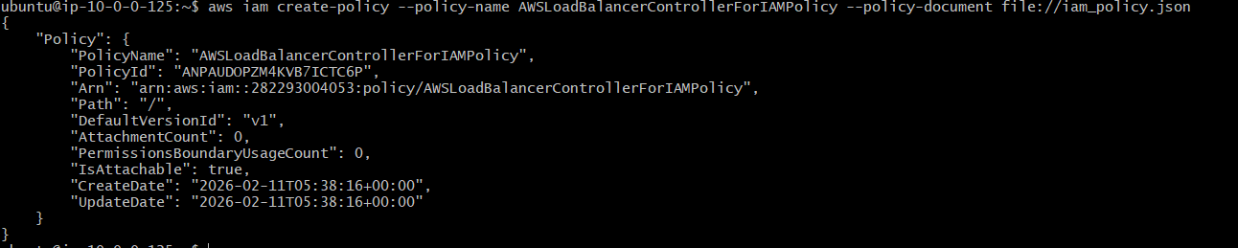

eksctl utils associate-iam-oidc-provider --region=eu-west-1 --cluster=three-tier-cluster --approve
eksctl create iamserviceaccount --cluster=three-tier-cluster --namespace=kube-system --name=aws-load-balancer-controller --role-name AmazonEKSLoadBalancerControllerRole --attach-policy-arn=arn:aws:iam::282293004053:policy/AWSLoadBalancerControllerForIAMPolicy --approve --region=eu-west-1
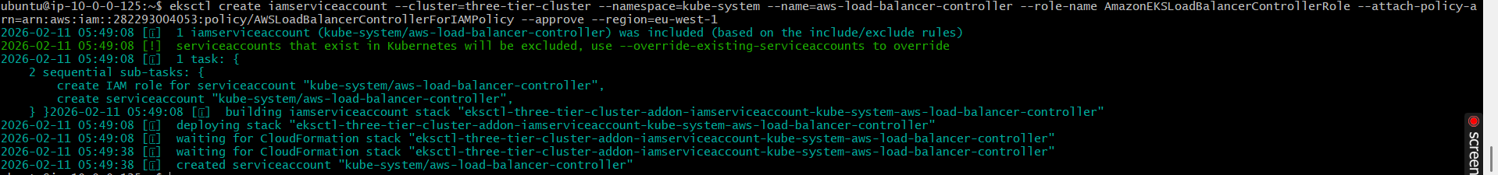

Explain: This controller allows EKS to automatically create ALB (Application Load Balancer) when you create an Ingress.

🔹 Step 1
aws iam create-policy --policy-name AWSLoadBalancerControllerForIAMPolicy --policy-document file://iam_policy.json
What this does (Simple Explanation)
You created a Permission Policy in AWS IAM.
Think of it like:
📄 A permission document that says
“This controller is allowed to create ALB, Target Groups, Security Groups, etc.”
Without this policy:
❌ Kubernetes cannot create ALB
❌ Ingress will fail

🔹 Step 2
eksctl utils associate-iam-oidc-provider --region=eu-west-1 --cluster=three-tier-cluster --approve
What this does
You connected:
🔗 Kubernetes Service Accounts ↔ AWS IAM Roles
This is called OIDC Provider.
In simple words:
“Allow Kubernetes pods to assume AWS IAM roles securely.”
Without this:
❌ Pods cannot use IAM permissions
❌ Controller cannot access AWS

🔹 Step 3
eksctl create iamserviceaccount ...
What this does
You created:
- ✅ Kubernetes Service Account
- ✅ IAM Role
- ✅ Attached the IAM Policy
- ✅ Linked them together
So now:
AWS IAM Policy
↓
IAM Role
↓
Kubernetes Service Account
↓
AWS Load Balancer Controller Pod
Now the controller pod has AWS permissions.
* Deploy AWS Load Balancer Controller
sudo snap install helm --classic
helm repo add eks https://aws.github.io/eks-charts
helm repo update eks
helm install aws-load-balancer-controller eks/aws-load-balancer-controller -n kube-system --set clusterName=three-tier-cluster --set serviceAccount.create=false --set serviceAccount.name=aws-load-balancer-controller
kubectl get deployment -n kube-system aws-load-balancer-controller
kubectl apply -f full_stack_lb.yaml

Explian : 🔹 1️⃣
sudo snap install helm --classic
What this means:
You installed Helm on your server.
👉 Helm = Package manager for Kubernetes
👉 Like apt for Ubuntu
👉 Like npm for Node
It helps install big applications easily (like Load Balancer Controller).

🔹 2️⃣
helm repo add eks https://aws.github.io/eks-charts
What this means:
You told Helm:
“Add AWS chart store so I can download AWS tools.”
Now Helm knows where AWS charts are stored.

🔹 3️⃣
helm repo update eks
What this means:
Helm downloads the latest chart list from AWS.
👉 Like refreshing app store.

🔹 4️⃣
helm install aws-load-balancer-controller eks/aws-load-balancer-controller \
-n kube-system \
--set clusterName=three-tier-cluster \
--set serviceAccount.create=false \
--set serviceAccount.name=aws-load-balancer-controller
What this means:
You installed the AWS Load Balancer Controller into your Kubernetes cluster.
Let’s break it:
Part | Meaning
aws-load-balancer-controller | Name of Helm release
eks/aws-load-balancer-controller | Chart location
-n kube-system | Install inside system namespace
clusterName=three-tier-cluster | Your EKS cluster name
serviceAccount.create=false | Don’t create new SA
serviceAccount.name=aws-load-balancer-controller | Use existing IAM-linked SA
👉 So now controller is running inside cluster.

🔹 5️⃣
kubectl get deployment -n kube-system aws-load-balancer-controller
What this means:
You are checking:
“Is the controller running?”
If you see:
2/2 READY
That means:
✅ Installed correctly
✅ Pods running
✅ Ready to create ALB
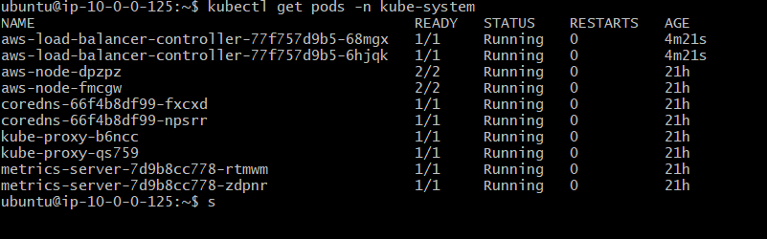

Now Crete Ingress
  - aws-eks-3tier-deployment/Kubernetes-Manifests-file$ nano ingress.yaml

apiVersion: networking.k8s.io/v1
kind: Ingress
metadata:
name: mainlb
namespace: three-tier
annotations:
alb.ingress.kubernetes.io/scheme: internet-facing
alb.ingress.kubernetes.io/target-type: ip
alb.ingress.kubernetes.io/listen-ports: '[{"HTTP": 80}]'
spec:
ingressClassName: alb
rules:
- host: backend.amanpathakdevops.study
http:
paths:
- path: /api
pathType: Prefix
backend:
service:
name: api
port:
number: 3500
- path: /
pathType: Prefix
backend:
service:
name: frontend
port:
number: 3000

apply the: kubectl apply -f ingress.yaml

  - kubectl get ing -n three-tier

